**Important Instructions:**

* Please read the document thoroughly before you code.
* Import the given skeleton code into your Visual Studio.
* Do not change the Skeleton code or the package structure, method names, variable names, return types, exception clauses, access specifiers etc.
* You can create any number of private methods inside the given class.
* You can test your code from main() method of the program

**Time: 2 hours**

**Assessment Coverage:**

* Classes and Objects
* Variables
* Loops
* Decision Constructs
* Collections

# **Requirement 1:**

**Problem Statement: Booking Doctor’s Appointment**

You are required to develop a C# console application to request a doctor’s appointment.

**Requirement 1:** Create a public class with the following properties.

**Class Name: PatientDetail**

|  |  |
| --- | --- |
| **Property Name** | **Data type** |
| PatientName | String |
| PatientAge | Int |

Note: The above properties must be public

**Requirement 2:**

|  |  |
| --- | --- |
| **Method Signature** | **Description** |
|  |  |
| public static List<string> GetDepartments() | Create a Method called “GetDepartments” which returns the list of departments in the “PatientDetail” class with the below values to represent the departments. |
|  |  |
|  |  |
| public static List<string> GetDoctors(int option) | Create another method GetDoctors which accepts the department as option and displays the list of doctors (Hint: Use Switch Case) |

**Refer the Below Table for the List of Departments and Respective Doctors:**

|  |  |
| --- | --- |
| **Department** | **Doctors** |
| ENT | Dr. Murugadoss MD DLO, Dr. Kalaivani MD DLO, Dr. Radha MD DLO |
| Gyanocologist | Dr. Bala Abirami MD DGO, Dr. Ramesh MD DGO, Dr. Revathi MD DGO |
| Pediatrician | Dr. Amudhan MD DCH, Dr. Gunaseelan MD DCH, Dr. Agarwal MD DCH |
| GeneralPhysician | Dr. Natarajan MD, Dr. Nanda MD, Dr. Keerthi MD |
| Cardiologist | Dr. Ashirvatham MD DM, Dr. Cherian MD DM, Dr. Ashwath MD DM |

**Requirement 4:** Create a public class with the following method to verify Appointment request functionality:

**Class Name: AppointmentDateVerification**

**Method:**

|  |  |
| --- | --- |
| **Method Signature** | **Description** |
|  |  |
| public string CheckappointmentRequestDate (DateTime appointmentRequestDate) | This method checks if the input appointment request date is a future date, from the current year and the day of the date is not a Monday. If all 3 conditions are true it returns “Appointment Confirmed!” along with a randomly generated number as Patient ID.  Else returns –   1. “Appointment Rejected, Date must be a future date!” 2. “Appointment Rejected, You can book appointment only for the current year!” 3. "Sorry!!! Appointment cannot be given on Monday!" |
|  |  |

**Requirement 5:** In the Main Program, Get the following details from the User (Patient Name, Patient Age, Department , DoctorName, Appointment request date), Validate & Display the output based on validation. Refer Sample Input/outputs below

**Sample I/O 1**

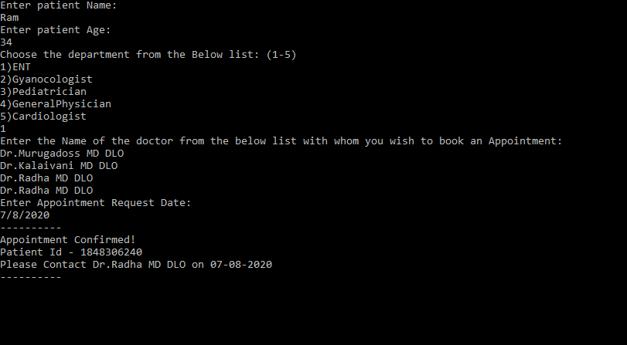

**Sample I/O 2**

